Instructions: Follow the steps and fill in the drop-down boxes. See website under Colors/Stamps to see options. Drop down boxes correspond to the images you see on website. Use notes at bottom to add additional information. Custom Leather work will not start until we talk, and I fully understand on what you want.

Thanks Trent

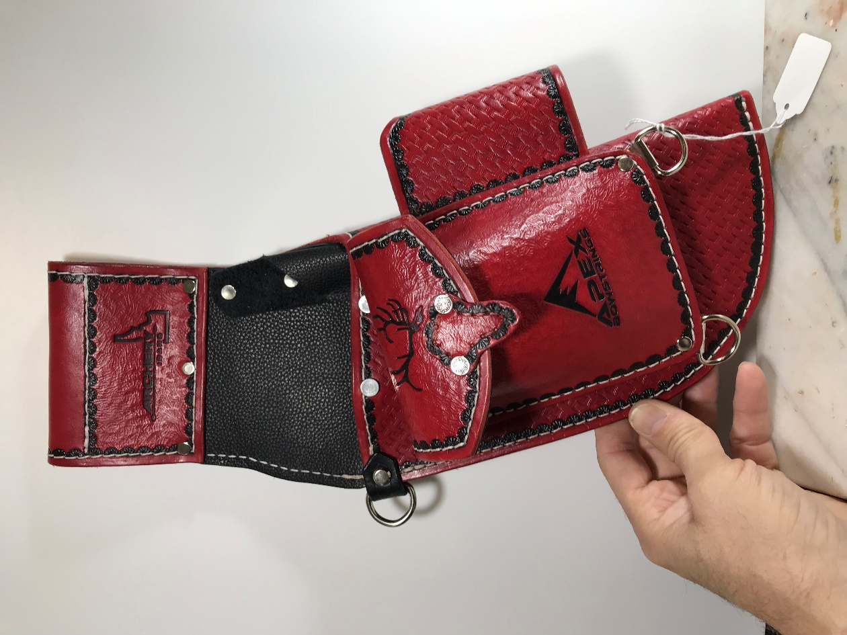

**Step 3 Edge Design**

**Step 6 Design**

**Step 5 Design**

**Step 4 Design**

**Step 7 Color**

**Step 2 Design**

**Step 9 Color**

**Step 8 Color**

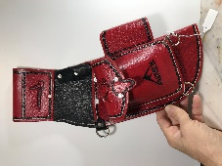 Trent’s Step 1 Tim’s 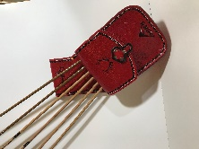

|  |  |  |  |  |  |
| --- | --- | --- | --- | --- | --- |
| ***Step 1*** | **Choose a quiver** |  | **Trent’s Custom Quiver** |  | **Tim’s Custom Quiver** |
| ***Step 2*** | **Choose quiver main body design** | **Basket Weave Stamps** | | **Choose an item.** | |
| **Background Stamps** | | **Choose an item.** | |
| ***Step 3*** | **Choose boarder-edge design** | **Boarder-Edge Stamps** | | **Choose an item.** | |
| ***Step 4*** | **Choose pattern you want on belt loop area** | **Initials, Name** | | **Click or tap here to enter text.** | |
|  |  | **Name and Number Stamps** | | **Choose an item.** | |
|  |  | **African Animals** | | **Choose an item.** | |
|  |  | **Arrow** | | **Choose an item.** | |
|  |  | **Bears** | | **Choose an item.** | |
|  |  | **Bighorn** | | **Choose an item.** | |
|  |  | **Birds** | | **Choose an item.** | |
|  |  | **Bison** | | **Choose an item.** | |
|  |  | **Coyote Wolf** | | **Choose an item.** | |
|  |  | **Deer** | | **Choose an item.** | |
|  |  | **Elk** | | **Choose an item.** | |
|  |  | **Fish** | | **Choose an item.** | |
|  |  | **Moose** | | **Choose an item.** | |
|  |  | **Mountain Goat** | | **Choose an item.** | |
|  |  | **Small Animals** | | **Choose an item.** | |
|  |  | **Snake** | | **Choose an item.** | |
|  |  | **Wild Cats** | | **Choose an item.** | |
|  |  | **Custom Design** | | **Click or tap here to enter text.** | |
|  |  | **Other Stamps** | | **Choose an item.** | |
| ***Step 5*** | **Choose pattern you want on upper pouch flap** | **Initials, Name** | | **Click or tap here to enter text.** | |
|  |  | **Name and Number Stamps** | | **Choose an item.** | |
|  |  | **African Animals** | | **Choose an item.** | |
|  |  | **Arrow** | | **Choose an item.** | |
|  |  | **Bears** | | **Choose an item.** | |
|  |  | **Bighorn** | | **Choose an item.** | |
|  |  | **Birds** | | **Choose an item.** | |
|  |  | **Bison** | | **Choose an item.** | |
|  |  | **Coyote Wolf** | | **Choose an item.** | |
|  |  | **Deer** | | **Choose an item.** | |
|  |  | **Elk** | | **Choose an item.** | |
|  |  | **Fish** | | **Choose an item.** | |
|  |  | **Moose** | | **Choose an item.** | |
|  |  | **Mountain Goat** | | **Choose an item.** | |
|  |  | **Small Animals** | | **Choose an item.** | |
|  |  | **Snake** | | **Choose an item.** | |
|  |  | **Wild Cats** | | **Choose an item.** | |
|  |  | **Custom Design** | | **Click or tap here to enter text.** | |
|  |  | **Other Stamps** | | **Choose an item.** | |
| ***Step 6*** | **Choose pattern you want on main body of pouch** | **Initials, Name** | | **Click or tap here to enter text.** | |
|  |  | **Name and Number Stamps** | | **Choose an item.** | |
|  |  | **African Animals** | | **Choose an item.** | |
|  |  | **Arrow** | | **Choose an item.** | |
|  |  | **Bears** | | **Choose an item.** | |
|  |  | **Bighorn** | | **Choose an item.** | |
|  |  | **Birds** | | **Choose an item.** | |
|  |  | **Bison** | | **Choose an item.** | |
|  |  | **Coyote Wolf** | | **Choose an item.** | |
|  |  | **Deer** | | **Choose an item.** | |
|  |  | **Elk** | | **Choose an item.** | |
|  |  | **Fish** | | **Choose an item.** | |
|  |  | **Moose** | | **Choose an item.** | |
|  |  | **Mountain Goat** | | **Choose an item.** | |
|  |  | **Small Animals** | | **Choose an item.** | |
|  |  | **Snake** | | **Choose an item.** | |
|  |  | **Wild Cats** | | **Choose an item.** | |
|  |  | **Custom Design** | | **Click or tap here to enter text.** | |
|  |  | **Other Stamps** | | **Choose an item.** | |
| ***Step 7*** | **Choose color of chap leather and pen holder** | **Midweight Biker Chap Leather** | | **Choose an item.** | |
| ***Step 8*** | **Choose the main color of quiver** | **Fiebing’s Professional Oil Dye** | | **Choose an item.** | |
| **Fiebing’s Leather Dye** | | **Choose an item.** | |
| **Fiebing’s Antique Leather Stain** | | **Choose an item.** | |
| **Fiebing’s Vintage Gel** | | **Choose an item.** | |
| **Angelus Leather Acrylic Paint** | | **Choose an item.** | |
| **Angelus Leather Dye** | | **Choose an item.** | |
| **Angelus Metallic Leather Paint** | | **Choose an item.** | |
| **Angelus Pearlescent Leather Paint** | | **Choose an item.** | |
| **Angelus Neon Acrylic Paint** | | **Choose an item.** | |
| **Angelus Collector Edition** | | **Choose an item.** | |
| ***Step 9*** | **Choose color of boarder** | **Fiebing’s Professional Oil Dye** | | **Choose an item.** | |
| **Fiebing’s Leather Dye** | | **Choose an item.** | |
| **Fiebing’s Antique Leather Stain** | | **Choose an item.** | |
| **Fiebing’s Vintage Gel** | | **Choose an item.** | |
| **Angelus Leather Acrylic Paint** | | **Choose an item.** | |
| **Angelus Leather Dye** | | **Choose an item.** | |
| **Angelus Metallic Leather Paint** | | **Choose an item.** | |
| **Angelus Pearlescent Leather Paint** | | **Choose an item.** | |
| **Angelus Neon Acrylic Paint** | | **Choose an item.** | |
| **Angelus Collector Edition** | | **Choose an item.** | |
| **Angelus Glow in Dark Paint** | | **Green Grow** | |
| ***Step 10*** | **Name** | **Click or tap here to enter text.** | | | |
|  | **Address** | **Click or tap here to enter text.** | | | |
|  | **Phone** | **Click or tap here to enter text.** | | | |
| ***Step 11*** | **Notes:**  **Let me know your thoughts!**  **If you have Company Logo, I can get a leather stamp made. (Extra Cost) But it can be use over and over.**  **Let me know if you want a custom scene.** | **Click or tap here to enter text.** | | | |